LAB TASK 07
QUESTION NO 01
#include <stdio.h>
int main() {
int mat[3][3] = {{4, 23, 3}, {4, 7, 6}, {7, 11, 9}};
int transpose[3][3];
int co_factors[3][3];
int ADJ[3][3];
float INV[3][3];
int i = 0, j = 0, k = 0, l = 0;
float det = 0;
for (i = 0; i < 3; i++) {
for (j = 0; j < 3; j++) {
transpose[i][j] = mat[j][i];
}
}
printf("TRANSPOSE\n");
for (i = 0; i < 3; i++) {
for (j = 0; j < 3; j++) {
printf("%d ", transpose[i][j]);
}
printf("\n");
}
for (i = 0; i < 3; i++) {
float m_d = 1, a_d = 1;
for (j = 0; j < 3; j++) {
m_d *= mat[j][(i + j) % 3];
a_d *= mat[j][(i - j + 3) % 3];
}
det += m_d - a_d;
}
printf("DETERMINANT\n%.2f\n", det);
for (i = 0; i < 3; i++) {
for (j = 0; j < 3; j++) {
int M[2][2];
int sr = 0;
for (k = 0; k < 3; k++) {
if (k == i) continue;
int sc = 0;
for (l = 0; l < 3; l++) {
if (l == j) continue;
M[sr][sc] = mat[k][l];
sc++;
}
sr++;
}
int det2 = M[0][0] * M[1][1] - M[0][1] * M[1][0];
if ((i + j) % 2 != 0) {
det2 = det2 * (-1);
}
co_factors[i][j] = det2;
}
}
printf("CO-FACTORS\n");
for (i = 0; i < 3; i++) {
for (j = 0; j < 3; j++) {
printf("%d ", co_factors[i][j]);
}
printf("\n");
}
for (i = 0; i < 3; i++) {
for (j = 0; j < 3; j++) {
ADJ[j][i] = co_factors[i][j];
}
}
printf("ADJOINT\n");
for (i = 0; i < 3; i++) {
for (j = 0; j < 3; j++) {
printf("%d ", ADJ[i][j]);
}
printf("\n");
}
if (det == 0) {
printf("INVERSE IS NOT POSSIBLE :/\n");
} else {
for (i = 0; i < 3; i++) {
for (j = 0; j < 3; j++) {
INV[i][j] = (float)(ADJ[i][j]) / det;
}
}

printf("INVERSE\n");
for (i = 0; i < 3; i++) {
for (j = 0; j < 3; j++) {
printf("%.2f ", INV[i][j]);
}
printf("\n");
}
}

return 0;
}
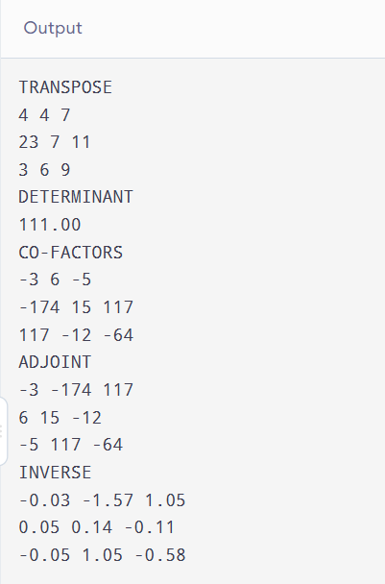
QUESTION NO 02
#include <stdio.h>
int main() {
int i = 0, j = 0, r = 0, c = 0, r2 = 0, c2 = 0;
int square = 0, zero = 0, identity = 0, diagonal = 0;
int scalar = 0, utri = 0, ltri = 0, skew = 0, symm = 0;
int sing = 0, nsing = 0, null = 0, idem = 0, nilpo = 0;
char n;

printf("Do You want to compare two matrices?\nY/N ");
scanf(" %c", &n);

if (n == 'Y' || n == 'y') {
printf("Enter number of rows of your first matrix (max 2): ");
scanf("%d", &r);
printf("Enter number of columns of your first matrix (max 2): ");
scanf("%d", &c);
printf("Enter number of rows of your second matrix (max 2): ");
scanf("%d", &r2);
printf("Enter number of columns of your second matrix (max 2): ");
scanf("%d", &c2);

int mat1[r][c], mat2[r2][c2];

for (i = 0; i < r; i++) {
for (j = 0; j < c; j++) {
printf("Enter mat1[%d][%d]: ", i, j);
scanf("%d", &mat1[i][j]);
}
}
for (i = 0; i < r2; i++) {
for (j = 0; j < c2; j++) {
printf("Enter mat2[%d][%d]: ", i, j);
scanf("%d", &mat2[i][j]);
}
}

if (r == r2 && c == c2) {
for (i = 0; i < r; i++) {
for (j = 0; j < c; j++) {
if (mat1[i][j] != mat2[i][j]) {
printf("Not Equal matrices.\n");
return 0;
}
}
}
printf("Equal matrices.\n");
return 0;
} else {
printf("Not equal Order.\n");
return 0;
}
} else {
printf("Enter number of rows of your matrix (max 2): ");
scanf("%d", &r);
printf("Enter number of columns of your matrix (max 2): ");
scanf("%d", &c);

int mat1[r][c];
for (i = 0; i < r; i++) {
for (j = 0; j < c; j++) {
printf("Enter mat1[%d][%d]: ", i, j);
scanf("%d", &mat1[i][j]);
}
}

if (r == 1) { row_mat: ; } // Placeholder or handled directly
if (r == c) { square = 1; }

zero = 1;
null = 1;
for (i = 0; i < r; i++) {
for (j = 0; j < c; j++) {
if (mat1[i][j] != 0) {
zero = 0;
null = 0;
}
}
}

if (square) {
identity = 1;
for (i = 0; i < r; i++) {
for (j = 0; j < c; j++) {
if ((i == j && mat1[i][j] != 1) || (i != j && mat1[i][j] != 0)) {
identity = 0;
}
}
}

diagonal = 1;
for (i = 0; i < r; i++) {
for (j = 0; j < c; j++) {
if (i != j && mat1[i][j] != 0) {
diagonal = 0;
}
}
}

scalar = diagonal;
if (diagonal && r > 0) {
int val = mat1[0][0];
for (i = 0; i < r; i++) {
if (mat1[i][i] != val) scalar = 0;
}
}

utri = 1;
for (i = 0; i < r; i++) {
for (j = 0; j < c; j++) {
if (i > j && mat1[i][j] != 0) utri = 0;
}
}

ltri = 1;
for (i = 0; i < r; i++) {
for (j = 0; j < c; j++) {
if (i < j && mat1[i][j] != 0) ltri = 0;
}
}

symm = 1;
for (i = 0; i < r; i++) {
for (j = 0; j < c; j++) {
if (mat1[i][j] != mat1[j][i]) symm = 0;
}
}

skew = 1;
for (i = 0; i < r; i++) {
for (j = 0; j < c; j++) {
if (mat1[i][j] != -mat1[j][i]) skew = 0;
}
}

int det = 0;
if (r == 1) det = mat1[0][0];
else if (r == 2) det = mat1[0][0] * mat1[1][1] - mat1[0][1] * mat1[1][0];

if (det == 0) sing = 1;
else nsing = 1;

if (r == 2) {
int m2[2][2] = {{0, 0}, {0, 0}};
int k = 0;
for (i = 0; i < 2; i++) {
for (j = 0; j < 2; j++) {
for (k = 0; k < 2; k++) {
m2[i][j] += mat1[i][k] * mat1[k][j];
}
}
}
idem = 1;
nilpo = 1;
for (i = 0; i < 2; i++) {
for (j = 0; j < 2; j++) {
if (m2[i][j] != mat1[i][j]) { idem = 0; }
if (m2[i][j] != 0) { nilpo = 0; }
}
}
}
}
}

printf("\nInformation about your matrix:\n");
if (r == 1) { printf("- ROW MATRIX\n"); }
if (c == 1) { printf("- COLUMN MATRIX\n"); }
if (square == 1) { printf("- SQUARE MATRIX\n"); }
else { printf("- RECTANGLE MATRIX\n"); }
if (null == 1) { printf("- NULL MATRIX\n"); }
if (zero == 1) { printf("- ZERO MATRIX\n"); }
if (square) {
if (identity == 1) { printf("- IDENTITY MATRIX\n"); }
if (diagonal == 1) { printf("- DIAGONAL MATRIX\n"); }
if (scalar == 1) { printf("- SCALAR MATRIX\n"); }
if (utri == 1) { printf("- UPPER TRIANGULAR MATRIX\n"); }
if (ltri == 1) { printf("- LOWER TRIANGULAR MATRIX\n"); }
if (symm == 1) { printf("- SYMMETRIC MATRIX\n"); }
if (skew == 1) { printf("- SKEW SYMMETRIC MATRIX\n"); }
if (sing == 1) { printf("- SINGULAR MATRIX\n"); }
else { printf("- NON-SINGULAR MATRIX\n"); }
if (idem == 1) { printf("- IDEMPOTENT MATRIX\n"); }
if (nilpo == 1) { printf("- NILPOTENT MATRIX\n"); }
}

return 0;
}
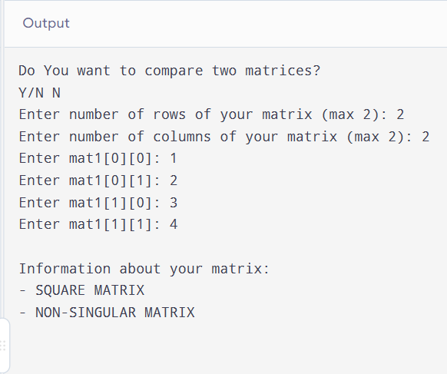
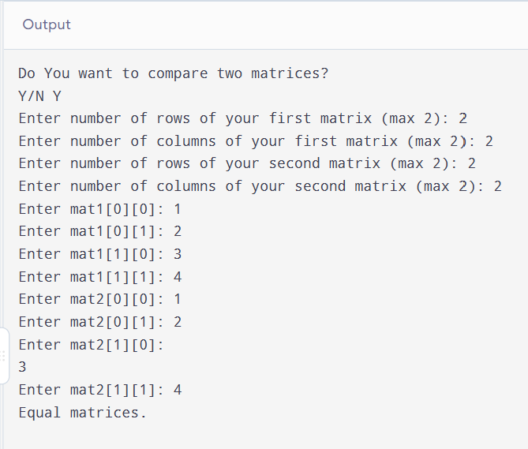
QUESTION NO 03
#include <stdio.h>

int main() {
int r1, c1, r2, c2;

printf("Enter rows and columns for Matrix A (max 3): ");
scanf("%d %d", &r1, &c1);

if (r1 < 1 || r1 > 3 || c1 < 1 || c1 > 3) {
printf("Error: Invalid dimensions for Matrix A. Must be between 1 and 3.\n");
return 0;
}

printf("Enter rows and columns for Matrix B (max 3): ");
scanf("%d %d", &r2, &c2);

if (r2 < 1 || r2 > 3 || c2 < 1 || c2 > 3) {
printf("Error: Invalid dimensions for Matrix B. Must be between 1 and 3.\n");
return 0;
}

if (c1 != r2) {
printf("\n[Validation Error] Multiplication not possible!\n");
printf("Columns of Matrix A (%d) must match Rows of Matrix B (%d).\n", c1, r2);
return 0;
}

int A[3][3], B[3][3], C[3][3] = {0};

printf("\nEnter elements of Matrix A (%dx%d):\n", r1, c1);
for (int i = 0; i < r1; i++) {
for (int j = 0; j < c1; j++) {
printf(" A[%d][%d]: ", i, j);
scanf("%d", &A[i][j]);
}
}

printf("\nEnter elements of Matrix B (%dx%d):\n", r2, c2);
for (int i = 0; i < r2; i++) {
for (int j = 0; j < c2; j++) {
printf(" B[%d][%d]: ", i, j);
scanf("%d", &B[i][j]);
}
}

for (int i = 0; i < r1; i++) {
for (int j = 0; j < c2; j++) {
C[i][j] = 0;
for (int k = 0; k < c1; k++) {
C[i][j] += A[i][k] * B[k][j];
}
}
}
printf(" RESULTS SUMMARY \n");
printf("Matrix A (%dx%d):\n", r1, c1);
for (int i = 0; i < r1; i++) {
for (int j = 0; j < c1; j++) {
printf("%6d ", A[i][j]);
}
printf("\n");
}

printf("\nMatrix B (%dx%d):\n", r2, c2);
for (int i = 0; i < r2; i++) {
for (int j = 0; j < c2; j++) {
printf("%6d ", B[i][j]);
}
printf("\n");
}

printf("\nResultant Matrix C (A x B) (%dx%d):\n", r1, c2);
for (int i = 0; i < r1; i++) {
for (int j = 0; j < c2; j++) {
printf("%6d ", C[i][j]);
}
printf("\n");
}
return 0;
}
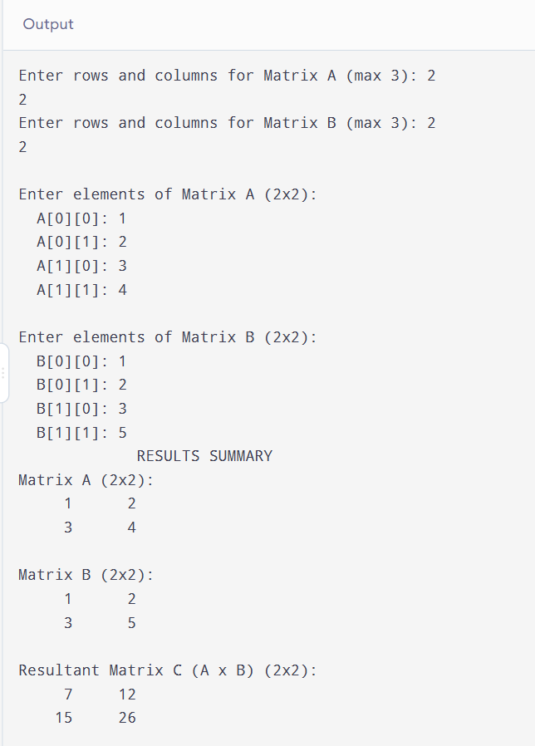
QUESTION NO 04
#include <stdio.h>
int main() {
int arr[3][3][3] = {
{
{ 2, 5, 8 },
{ 1, 4, 7 },
{ 3, 6, 9 }
},
{
{12, 15, 18 },
{11, 14, 17 },
{13, 16, 19 }
},
{
{22, 25, 28 },
{21, 24, 27 },
{23, 26, 29 }
}
};

int total_elements = 3 * 3 * 3;
long long grand_total = 0;
int global_min = arr[0][0][0];
int global_max = arr[0][0][0];
printf(" 3x3x3 3D ARRAY ANALYTICS REPORT \n");
for (int i = 0; i < 3; i++) {
long long layer_sum = 0;
int layer_min = arr[i][0][0];
int layer_max = arr[i][0][0];
for (int j = 0; j < 3; j++) {
for (int k = 0; k < 3; k++) {
int current_val = arr[i][j][k];
layer_sum += current_val;
if (current_val < layer_min) layer_min = current_val;
if (current_val > layer_max) layer_max = current_val;
grand_total += current_val;
if (current_val < global_min) global_min = current_val;
if (current_val > global_max) global_max = current_val;
}
}
double layer_avg = (double)layer_sum / 9.0;
printf("--- Layer %d (Depth Index %d) ---\n", i + 1, i);
printf(" * Layer Total Sum : %lld\n", layer_sum);
printf(" * Layer Average : %.2f\n", layer_avg);
printf(" * Layer Minimum : %d\n", layer_min);
printf(" * Layer Maximum : %d\n", layer_max);
printf("\n");
}
double grand_avg = (double)grand_total / (double)total_elements;
printf(" OVERALL DATA INSIGHTS \n");
printf(" * Total Elements Processed : %d\n", total_elements);
printf(" * Grand Total Sum : %lld\n", grand_total);
printf(" * Overall Average : %.2f\n", grand_avg);
printf(" * Global Minimum : %d\n", global_min);
printf(" * Global Maximum : %d\n", global_max);

return 0;
}
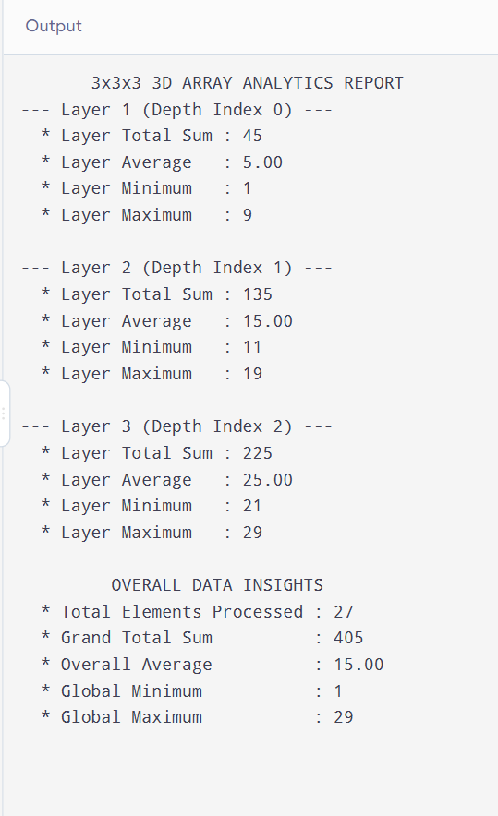
QUESTION NO 05
#include <stdio.h>
int main() {
int arr[3][3][3] = {
{
{ 1, 2, 3 },
{ 4, 5, 6 },
{ 7, 8, 9 }
},
{
{ 9, 8, 7 },
{ 6, 5, 4 },
{ 3, 2, 1 }
},
{
{ 1, 2, 3 },
{ 4, 5, 6 },
{ 7, 8, 9 }
}
};
printf(" 3x3x3 MATRIX SET LAYER SIMILARITY ANALYSIS \n");
for (int l = 0; l < 3; l++) {
printf("--- Layer %d Matrix ---\n", l);
for (int r = 0; r < 3; r++) {
for (int c = 0; c < 3; c++) {
printf("%5d ", arr[l][r][c]);
}
printf("\n");
}
printf("\n");
}
printf(" PAIRWISE LAYER SIMILARITY REPORT \n");
int pairs[3][2] = {
{0, 1},
{0, 2},
{1, 2}
};
for (int p = 0; p < 3; p++) {
int l1 = pairs[p][0];
int l2 = pairs[p][1];
int is_identical = 1;
for (int r = 0; r < 3; r++) {
for (int c = 0; c < 3; c++) {
if (arr[l1][r][c] != arr[l2][r][c]) {
is_identical = 0;
break;
}
}
if (!is_identical) break;
}
printf("Comparison: Layer %d vs Layer %d = ", l1, l2);
if (is_identical) {
printf("[IDENTICAL]\n");
} else {
printf("[DISTINCT]\n");
}
}

return 0;
}
